

Ms . Alluri Swathi
CHERUKUMALLI VIVEK
2520030532
CSE
Co-2
CivicEye-Smart City Incident Monitoring & Response System

The CivicEye system enables citizens to report city incidents and allows authorities to monitor and resolve them efficiently. It maintains organized incident records, provides real-time tracking, and improves communication between citizens and city officials. The use of advanced data structures ensures fast data processing and effective incident management. Overall, the system enhances public safety and supports smart city governance.

Implementation Details:
- Implemented Binary Search Tree (BST) to store and search incidents using IncidentID.
- Used AVL Tree for balancing city complaint databases.
- Applied tree traversals (Inorder, Preorder, Postorder) to generate sorted incident reports.
- Performed AVL rotations (LL, RR, LR, RL) whenever imbalance occurred.
- Compared BST and AVL performance for incident record management.
- Concluded AVL Tree improves efficiency for large-scale smart city monitoring systems.

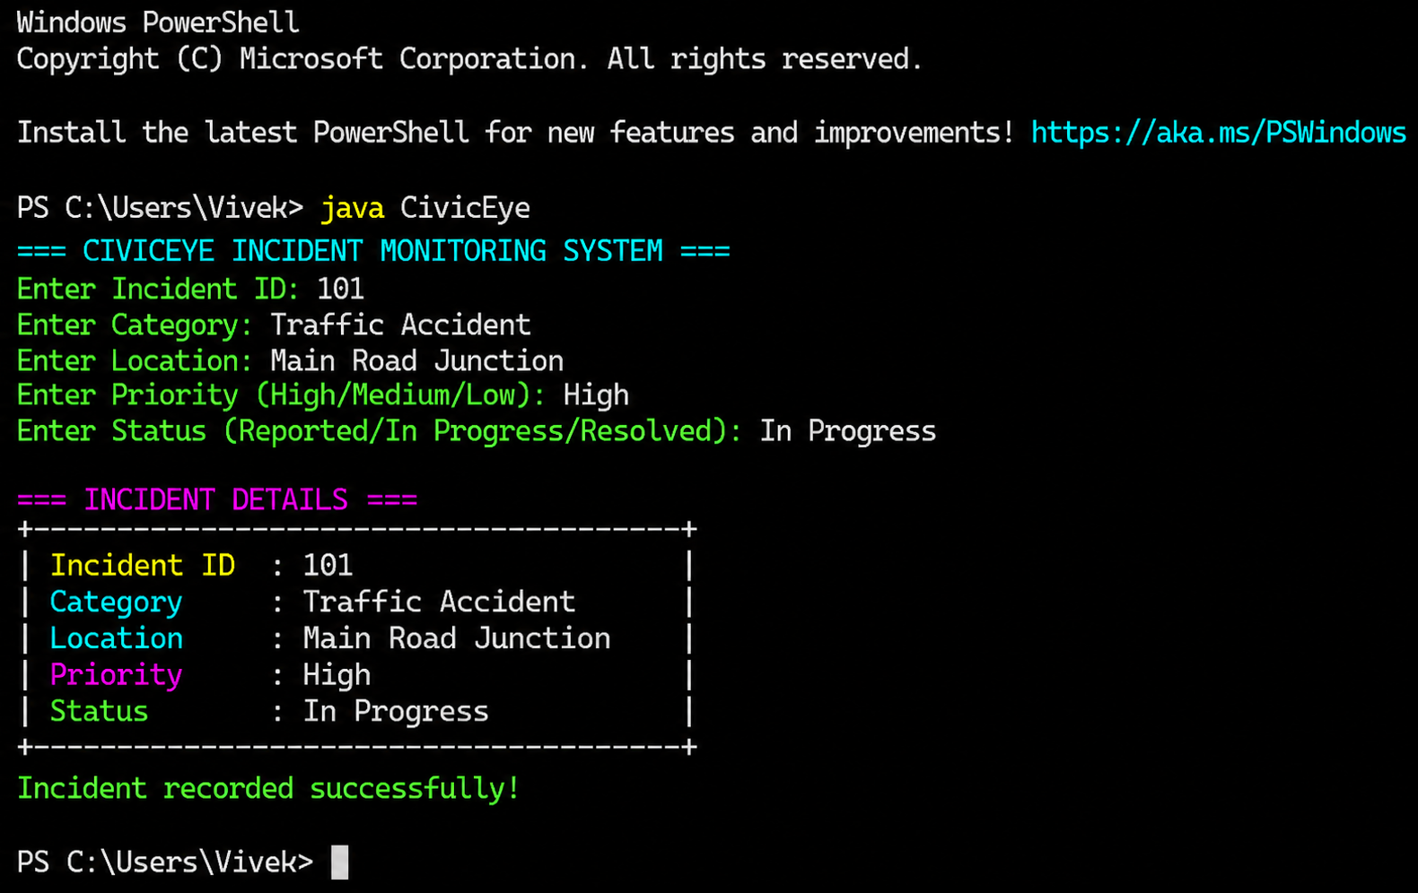
https://github.com/vivekcherukumalli7-beep/DSA2_CIVICEYE_PROJECT

